Coon Rapids High School  Athletic Department | Jeremy Sheppard MS, ATC, CES  Cell Phone: 612-998-9785  Email: JeremySheppard@tcomn.com

Pre-Season Informational Letter

Our 2021-2022 sports seasons are starting, and it’s time for the Athletics staff to prepare for a safe and successful season. As the school’s Licensed Athletic Trainer, it is important for me to communicate with all coaches, student-athletes and parents in order to provide quality services for Coon Rapids High School athletics through Twin Cities Orthopedics. I hope this letter will provide you with ample information on how I strive to provide a positive experience for your student-athlete here at Coon Rapids.

What is an Athletic Trainer?

Athletic trainers are highly skilled healthcare professionals trained in the prevention, evaluation, and treatment of injury and illness. From the onset of injury or illness through the recovery process, an athletic trainer is trained to work with your student-athlete through the entire process. The core competencies of an athletic trainer include:

- Injury and Illness Prevention and Wellness Promotion
- Examination, Assessment, and Diagnosis
- Immediate and Emergency Care
- Therapeutic Intervention
- Healthcare Administration and Professional Responsibility

Additional information on the profession of athletic training can be found by visiting: https://www.atyourownrisk.org/

Twin Cities Orthopedics is taking every possible measure to ensure the safety of our student-athletes, using recommendations from the Minnesota Department of Health (MDH) and the Center for Disease Control (CDC) along with guidelines set by the school and/or district.

This information letter will walk you through the services that are available to you. Please feel free to reach out with any questions.

Sports Medicine, Physical Therapy and Rehabilitation Services

About Twin Cities Orthopedics

Twin Cities Orthopedics (TCO) is committed to providing world-class service. TCO’s dedicated teams of independent physicians, specialty providers and care coordinators serve patients in clinic locations, walk-in orthopedic urgent care locations, and numerous other therapy and specialty care settings across Minnesota and western Wisconsin. Regardless of the location, TCO delivers an exceptional patient experience, backed by decades of trusted orthopedic and sports medicine care.

To learn more, visit TCOmn.com.

TCO’s programs include:

- Orthopedic Urgent Care clinics, open 7 days a week from 8am – 8pm

TCO Blaine | TCO Eagan – Viking Lakes | TCO Maple Grove | TCO Waconia
TCO Burnsville | TCO Edina – Crosstown | TCO Stillwater* | TCO Woodbury

*Orthopedic Urgent Care opening Fall 2021

- Specialty Programs offered through Twin Cities Orthopedics (at various locations):

Sports Injury Prevention | Biometric Training/Testing | Running Program
Functional Movement Screening (FMS) | Nutrition Services | Concussion/Vestibular
Athletic Competition Enhancement (ACE) | Sports Chiropractic Services | Soccer
Golf Medicine | Sports Massage | TRAC
Throwing/Baseball | Sports Psychology | Aquatic Therapy
Blood Flow Restriction | Dry Needling | Sports Nutrition

- Training HAUS Powered by TCO

Training HAUS, with a flagship location in Eagan, is an elite athletic performance and recovery philosophy that is unparalleled in the Twin Cities. Utilizing innovative, science-based methods, our industry-leading team of experts work together to form a personalized approach for the athlete. Collectively, we establish a foundation for athletic performance that promises to challenge, inspire and produce real results. Sports performance services are available at the Training HAUS flagship location in Eagan, TCO Sports Performance facilities or at your school, field or facility.

To learn more, visit TrainingHAUS.com.

Primary TCO Clinic Location

As your Licensed Athletic Trainer, I will be utilizing the following TCO clinic, therapy and performance locations as the primary locations I refer to in order to provide our student-athletes with a complete injury care and management program.

TCO Blaine
11225 Ulysses St NE | Blaine, MN 55434
763-302-2600

A wide range of health plans are accepted, and self-referrals are welcome. Please contact your insurance carrier directly for coverage details.

Coon Rapids High School
Jeremy Sheppard MS, ATC, CES
612-998-9785| JeremySheppard@tcomn.com

Hours and Sideline Coverage

Although I do not attend all events, all the student-athletes at all levels of play are welcome to seek out my care in the Athletic Training Room.

Hours

- Fall and Winter seasons – 2:00pm – 5:30pm
- Spring season – 2:00pm – 5:30pm

Coverage

Football - all levels (traveling with only varsity), Volleyball – all levels, Boys and Girls Soccer – all levels, Cross Country, Boys and Girls Basketball (V/JV), Boys and Girls Hockey (V/JV), Wrestling (V/JV), and Gymnastics (V/JV), Dance Team, Baseball (Varsity only), Softball (Varsity only), Track and Field (Varsity only) and Boys and Girls Lacrosse (Varsity)

Healthy Roster

All TCO athletic trainers working in the high school setting will be utilizing Healthy Roster as our electronic medical record platform for your student-athlete in 2021-2022. Healthy Roster gives us an efficient, protected platform for documentation purposes and provides a secure communication platform for me to discuss injury details with parents, coaches, and administrators as necessary. For more information on Healthy Roster, visit https://www.healthyroster.com

I will contact parents/guardians as needed in the event of an emergency. If you have questions, concerns or would like to discuss the plan of action for your child’s injury, please contact me at:

- Phone – 612-998-9785
- Email – JeremySheppard@tcomn.com

Concussion Management

Primary concussion management will be provided through the site Licensed Athletic Trainer, the student-athlete will then be referred to a sports medicine trained physician if deemed necessary. Referrals to a Sports Concussion Specialist are available and may be made based on your symptoms. If you would prefer to work with a physician regarding a concussion, please contact your Licensed Athletic Trainer so they can assist you in seeing a physician trained to treat this type of injury.

The ImPACT concussion test is a tool we have available to our student-athletes to help us in our clinical diagnosis and return to activity decisions. This is a computer-based test that uses multiple different tasks to determine aspects such as memory recall, reaction time, etc. This test is not required for participation in athletics by the school or the Licensed Athletic Trainer but may be required per coach’s discretion. If you would like your child to take a pre-injury baseline ImPACT test (should the event of a concussion occur it is beneficial to have a baseline in order to compare results rather than using the normative data) please contact Jeremy Sheppard for administration of the test.

Concussion Return to Play management will be supervised by your Licensed Athletic Trainer according to the Minnesota State High School League guidelines. There is a mandatory 24 hours between each of the 5 phases of supervised return to play.

Please contact your Licensed Athletic Trainer with any questions.

Physician Visits

If your child is in need of a physician visit during the year due to an injury, please contact me directly and I will assist you with identifying a sports medicine physician. I can also facilitate a quicker appointment through the use of our team physician and supervising clinic.

For ALL doctor visits:

According to the Minnesota State High School League Rule (Bylaw 107.00), if your child receives care from a physician for injury or illness “the attending physician must certify in writing the students readiness to return to competition.” THE ATHLETE WILL NOT BE ALLOWED TO PARTICIPATE WITHOUT A NOTE FROM A PHYSICIAN STATING SPECIFIC CLEARANCE FOR ACTIVITY.

Sideline Team

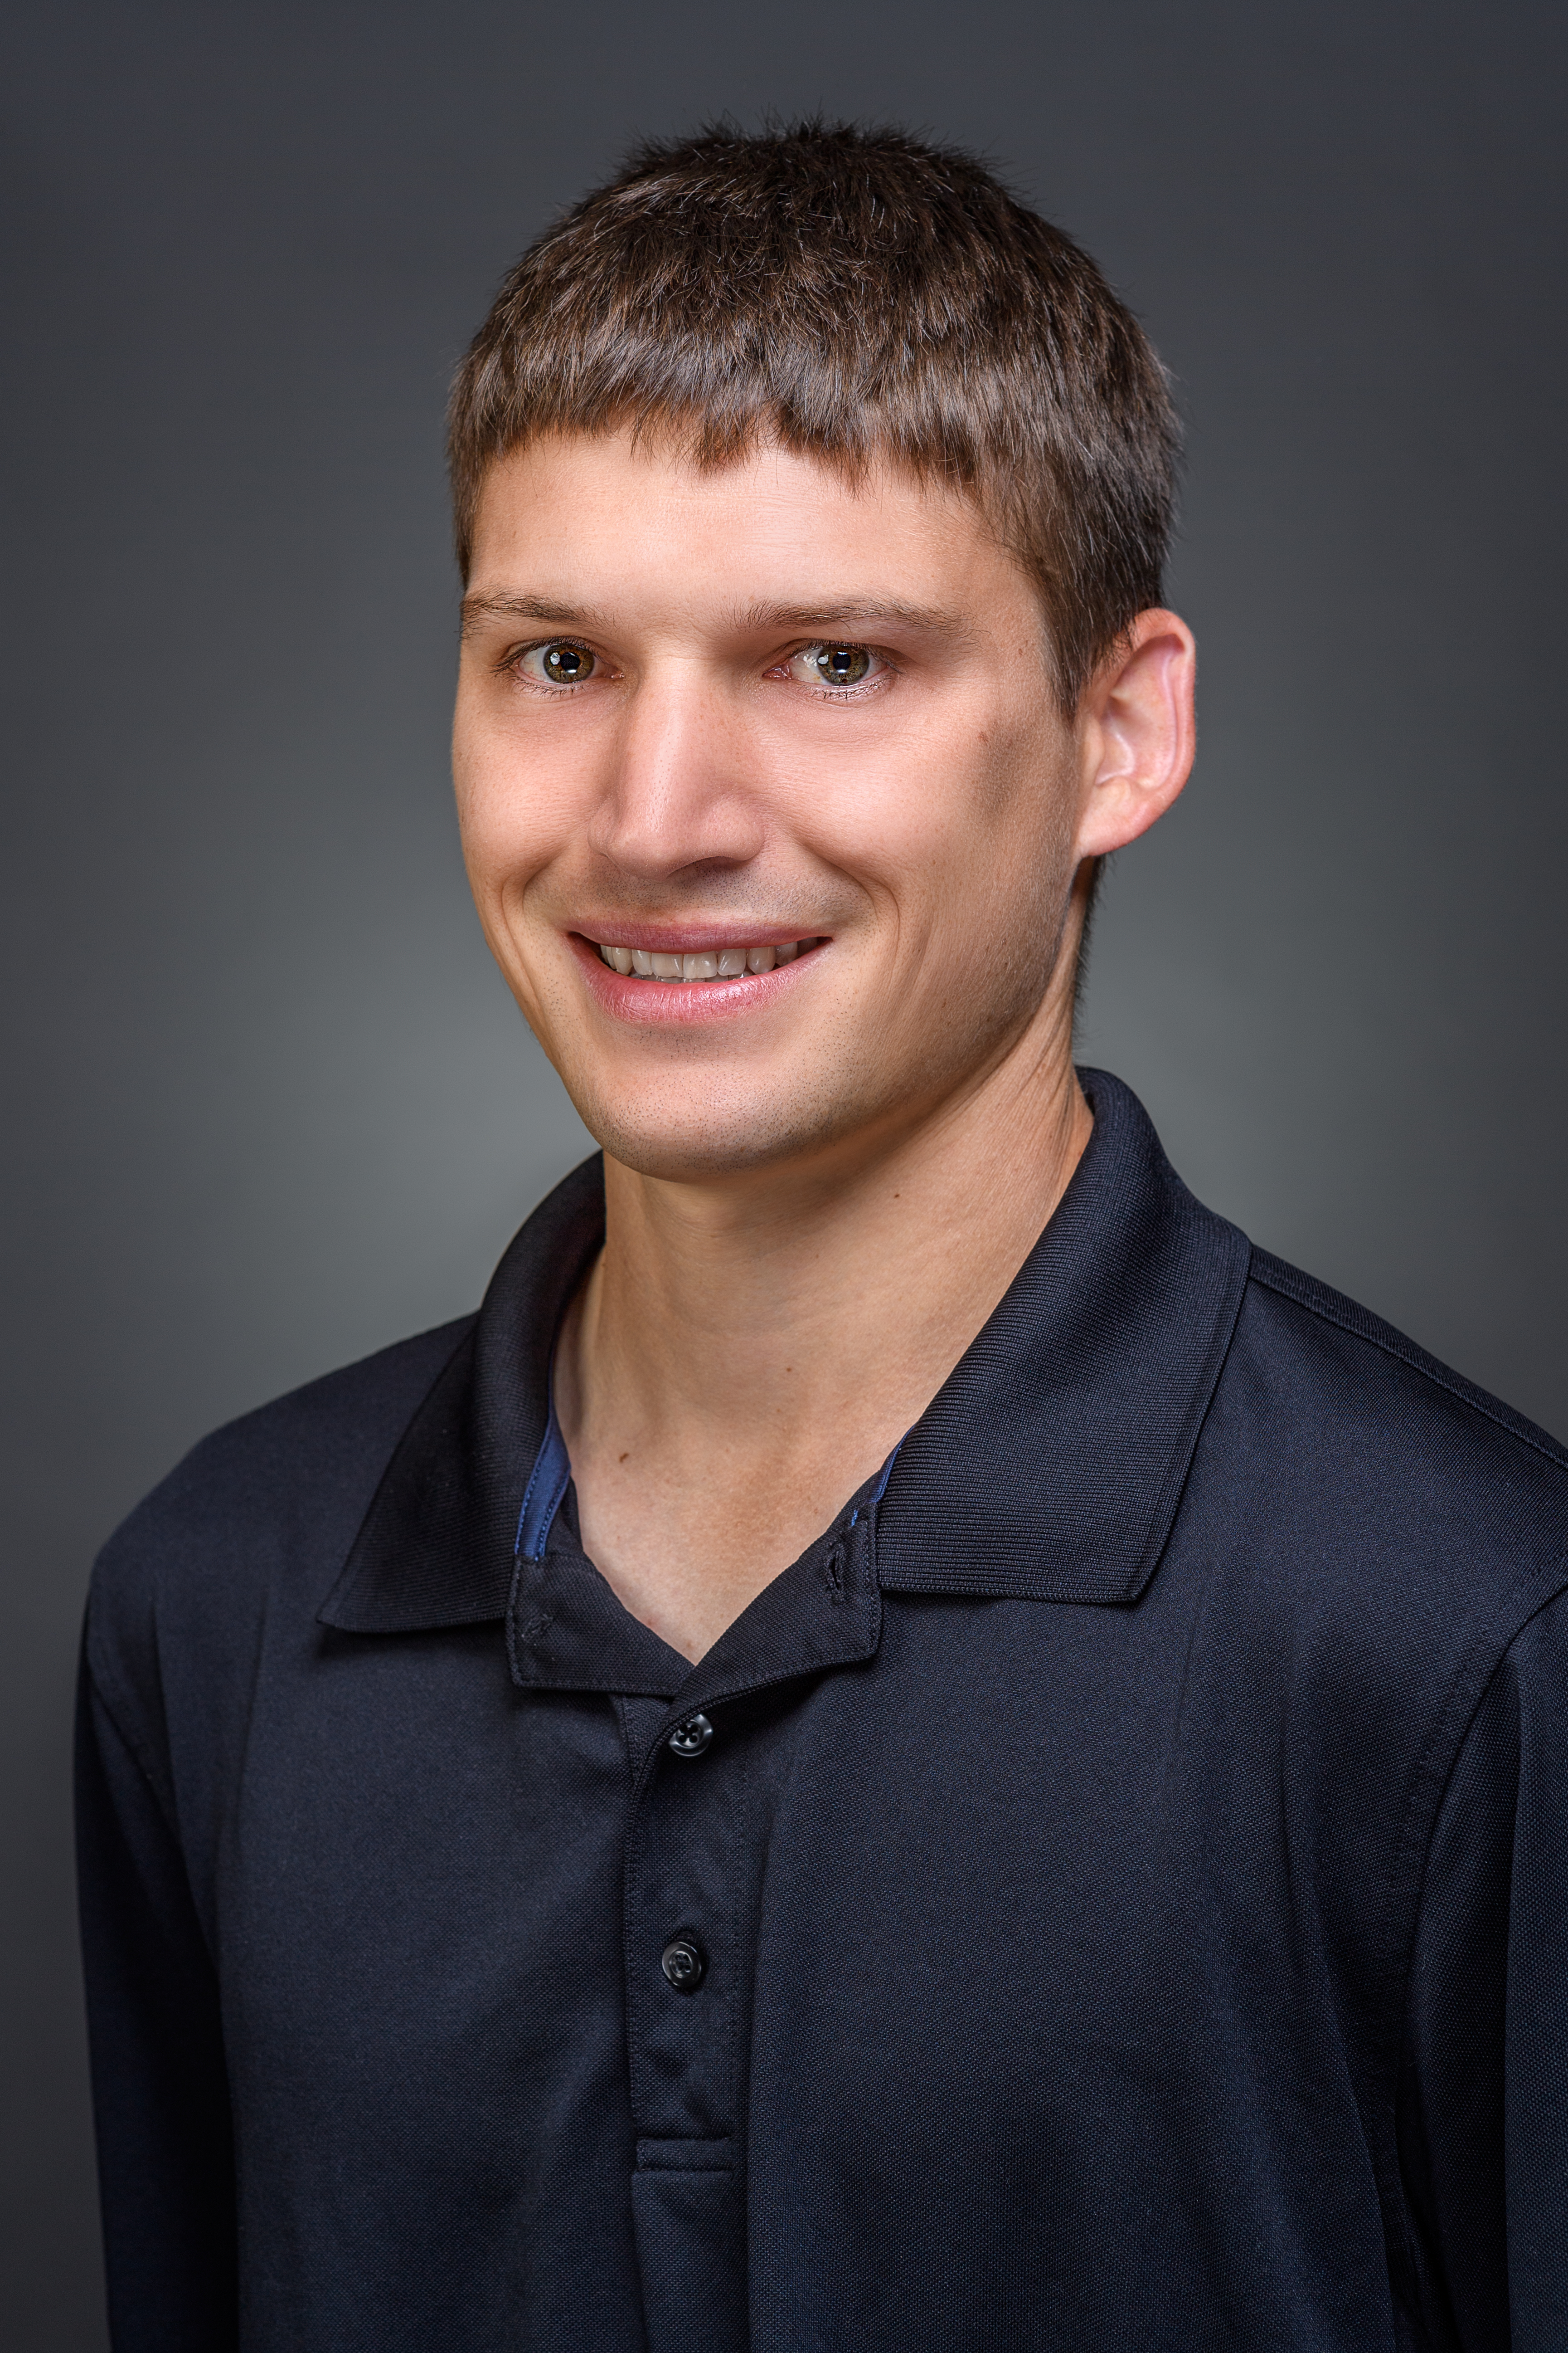 | Jeremy Sheppard, MS, ATC, CES  Licensed Athletic Trainer | Coon Rapids High School  Education:  Northwestern College Iowa – BS in Athletic Training  California University of Pennsylvania – MS in Exercise Science and Wellness – Rehabilitation Sciences  Number of Years at Coon Rapids: 5  JeremySheppard@tcomn.com|612-998-9785

COVID-19 Safety Precautions and Expectations

With the current climate surrounding COVID-19, there are additional measures that need to be taken to ensure the safety of our staff, patients, and their families. Below are current recommendations based on current available evidence. Any TCO staff members covering events or working in an outreach setting must adhere to these guidelines.

Please stay up to date on current CDC and Minnesota Department of Health guidelines for PPE and social distancing as these may be updated at any time.

Coon Rapids Licensed Athletic Trainer: PPE

- Masking Indoors – Per CDC guidelines, N95 mask must be worn at all times

- Gloves – Gloves may be worn when performing evaluation and working with patients. If gloves are not being used there will be hand washing or hand sanitizing before and after each patient contact.

- Eye Protection – Eye protection may be worn when interacting with patients; although, not required.

Other Athletic Training Room Considerations

- Follow CDC guidelines for social distancing
- Don’t allow the athletic training room to become overcrowded
- Utilize sign-in sheets with sign in and sign out time to assist with contact tracing
- Athletes should wash/sanitize hands when entering and exiting
- Eliminate use of ice baths/whirlpools for non-emergencies.

Sanitizing Procedures

- Treatment tables and equipment should be cleaned between each patient use
- Frequently touched surfaces should be cleaned regularly
- Note: If bottles/coolers are being used they must be thoroughly cleaned after each use. Consider single use products when available, including wipes, paper towels, etc.

COVID-19 Resources for Coaches, Student-Athletes and Families
*Please note that these are subject to change per Minnesota Department of Health and the most up to date information should be found on their website

- COVID-19 Sports Guidance for Youth & Adults
- https://www.health.state.mn.us/diseases/coronavirus/sportsguide.pdf

- COVID-19 Prevention Guidance for Youth and Student Programs
https://www.health.state.mn.us/diseases/coronavirus/schools/socialdistance.pdf

- COVID-19 What to do if you’re waiting for test results
https://www.health.state.mn.us/diseases/coronavirus/waiting.pdf

- COVID-19 MSHSL NOTICE
https://www.mshsl.org/sites/default/files/2020-08/mshsl-covid-final-notice.pdf

Coon Rapids High School
Jeremy Sheppard, MS, ATC, CES
612-998-9785 | JeremySheppard@tcomn.com

